NATIONAL DIVISIONS DIABETES PROGRAM

DIVISIONS DIABETES & CARDIOVASCULAR QUALITY
IMPROVEMENT PROJECT

MEDICATIONS ANALYSIS

DRAFT REPORT

Centre for General Practice Integration Studies
School of Public Health & Community Medicine
University of New South Wales
UNSW 2052

Table of Contents

1.Frequency counts (Type 2 patients only) of all eligible Division data 1
2. Medications analysis for Type 2 patients >25 BMI by year 2
3. Medications for Type 2 patients with HbA1c >1% ULN 3
4. Type 2 patients on lipid treatment, who recorded a visit to their GP in any given year with Total Cholesterol >= 5mmol/L 4
5. Type 2 patients with GP visit in any given year with BP >130/85: % on ACEi. 4
6. Type 2 patients with GP visit in any given year with albumuria. % on ACEi. 5
7. Cohort analysis of Type 2 patients) on Lipid treatment. 6
8. Cohort analysis of Type 2 patients with >130/85 mm/Hg on ACEi 7
9. Cohort analysis of Type 2 patients with albuminuria on ACEi 8
10. Cohort analysis of Type 2 HbA1c groupings and medication (2000-2002) 9

1.Frequency counts (Type 2 patients only) of all eligible Division data  - Six Divisions were excluded from the analysis. Three of these Divisions (291, 709, 965) did not have a functioning register across each of the three years and three (612, 654, 761) had a register that had deteriorated in the course of the three years.  - Analysis of each year was based on patient recording at least one visit to the GP in any given year.  - Tablet medication was the only major change over 2000-2002.  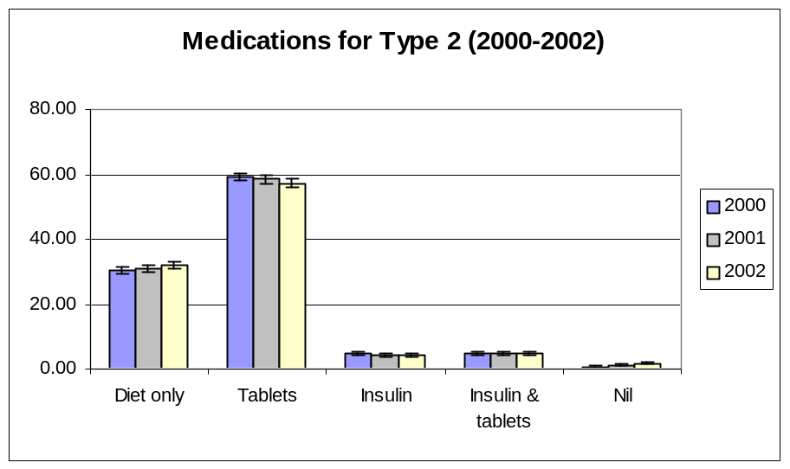
  All Type 2 patients | 2000 | 2001 | 2002
  Diet only | 1535  30.3% | 1854  31.1% | 2240  32.0%
  Tablets | 3001  59.2% | 3482  58.5% | 4007  57.3%
  Insulin | 252  5.0% | 255  4.3% | 290  4.1%
  Insulin & tablets | 248  4.9% | 282  4.7% | 326  4.7%
  Nil | 29  0.6% | 79  1.3% | 128  1.8%
  Total | 5506 | 6610 | 6991
2. Medications analysis for Type 2 patients >25 BMI by year  For Type 2 patients >25 BMI, tablets Rx fell the most over the period 2000-2002. This was the only significant change. | 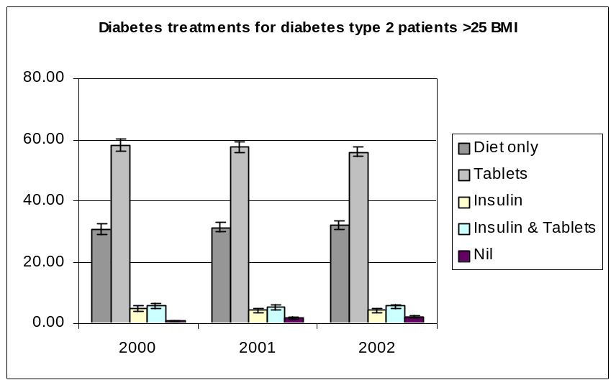
  All Type 2 patients >25 BMI | 2000 | 2001 | 2002
  Diet only | 783  30.6% | 951  31.4% | 1319  32.1%
  Tablets | 1486  58.1% | 1743  57.5% | 2299  55.9%
  Insulin | 129  5.0% | 128  4.2% | 175  4.3%
  Insulin & tablets | 141  5.5% | 157  5.2% | 231  5.6%
  Nil | 18  0.7% | 53  1.7% | 87  2.1%
  Total | 2557 | 3032 | 4111
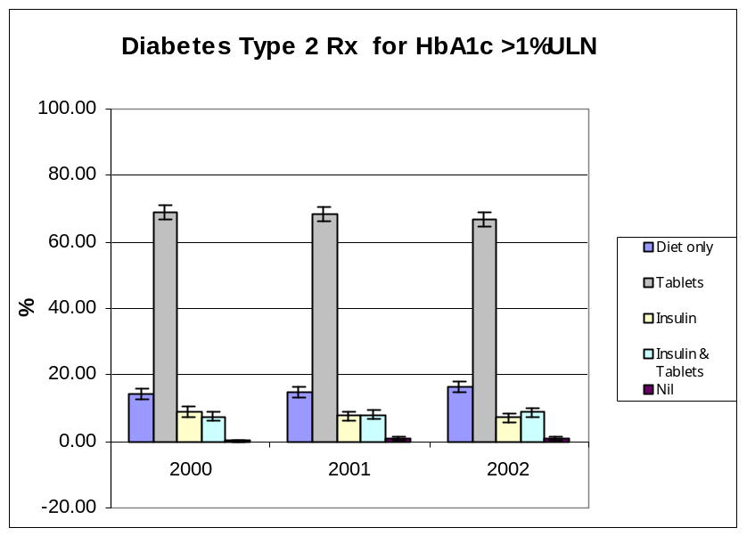 | 3. Medications for Type 2 patients with HbA1c >1% ULN  There were no significant differences in medication patterns for Type 2 patients with HbA1c > 1%ULN.
  All Type 2 HbA1c >1%ULN |  | 2000 | 2001 | 2002
  Diet only | n | 222 | 247 | 313
   | % | 14.40 | 14.80 | 16.60
   | CI | 1.75 | 1.71 | 1.68
  Tablets | n | 1065 | 1138 | 1253
   | % | 69.00 | 68.30 | 66.60
   | CI | 2.31 | 2.23 | 2.13
  Insulin | n | 137 | 130 | 134
   | % | 8.9 | 7.8 | 7.1
   | CI | 1.42 | 1.29 | 1.16
  Insulin & tablets | n | 116 | 135 | 165
   | % | 7.5 | 8.1 | 8.8
   | CI | 1.31 | 1.31 | 1.28
  Nil | n | 3 | 16 | 15
   | % | 0.2 | 1 | 0.8
   | CI | 0.22 | 0.52 | 0.40
4. Type 2 patients on lipid treatment, who recorded a visit to their GP in any given year with Total Cholesterol >= 5mmol/L  Results were not significant. | 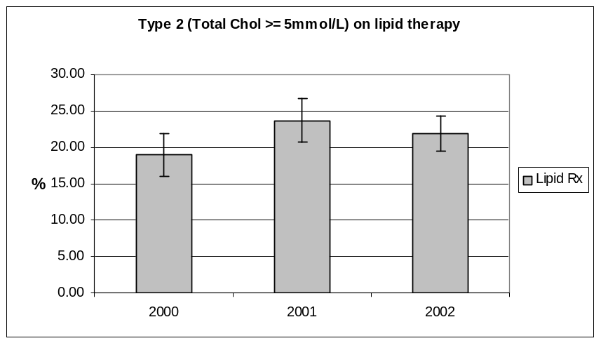
  Pts with visit and =>5mmol/L on lipid rx |  | 2000 | 2001 | 2002
  Lipid rx | Total n | 677 | 771 | 1157
   | % | 18.90 | 23.70 | 21.90
   | CI | 2.95 | 3.00 | 2.38
   | lower | 15.95 | 20.70 | 19.52
   | upper | 21.85 | 26.70 | 24.28
   | n | 128 | 183 | 253
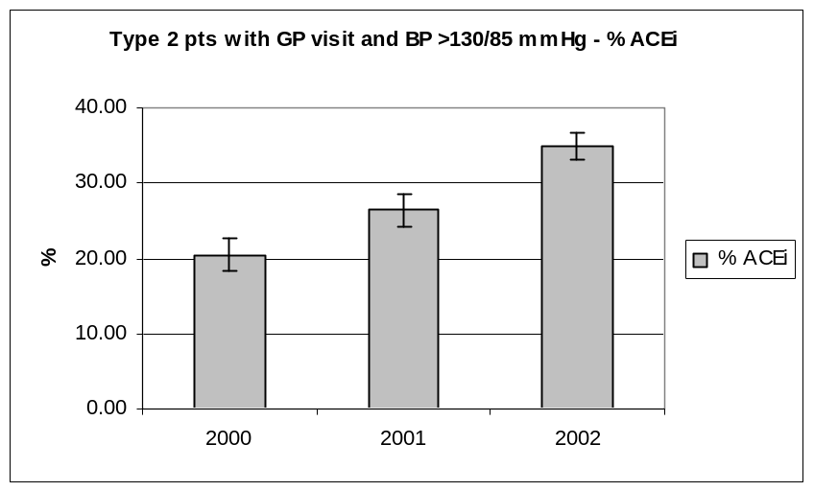 | 5. Type 2 patients with GP visit in any given year with BP >130/85: % on ACEi.  The results of the analysis of Type 2 patients with Blood Pressure >130/85 mmHg (who visited their GP in any given year) show that there were significant differences between the % in 2000 to 2002 and between 2000 to 2002.
  .Type 2 patients who visited GP in any given year, with BP >130/85 on ACEi |  | 2000 | 2001 | 2002
  ACEi | n | 274 | 417 | 851
   | % | 20.40 | 26.40 | 34.90
   | CI | 2.16 | 2.17 | 1.89
   | lower | 18.24 | 24.23 | 33.01
   | upper | 22.56 | 28.57 | 36.79
   | Total n | 1342 | 1578 | 2441
6. Type 2 patients with GP visit in any given year with albumuria. % on ACEi.  The results of the analysis of Type 2 patients with albuminuria (who visited their GP in any given year show that there were significant differences between the % in 2000 to 2002 and between 2001 to 2002. | 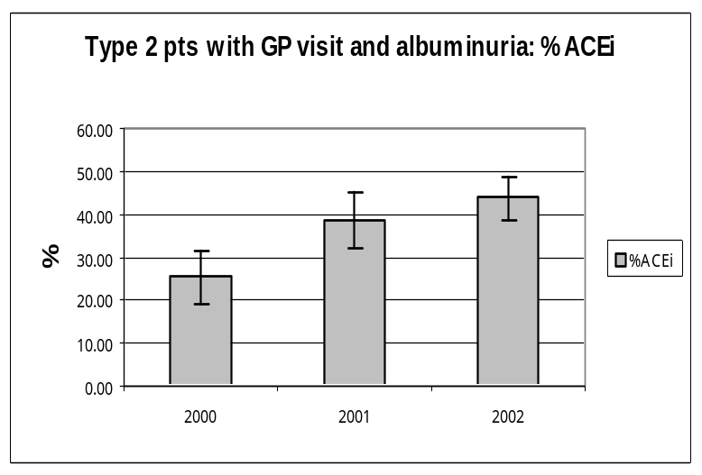
  Type 2 patients who visited GP in any given year, with albuminuria on ACEi |  | 2000 | 2001 | 2002
  ACEi | n | 49 | 83 | 172
   | % | 25.30 | 38.40 | 43.70
   | CI | 6.12 | 6.49 | 4.90
   | lower | 19.18 | 31.91 | 38.80
   | upper | 31.42 | 44.89 | 48.60
   | Total n | 194 | 216 | 394
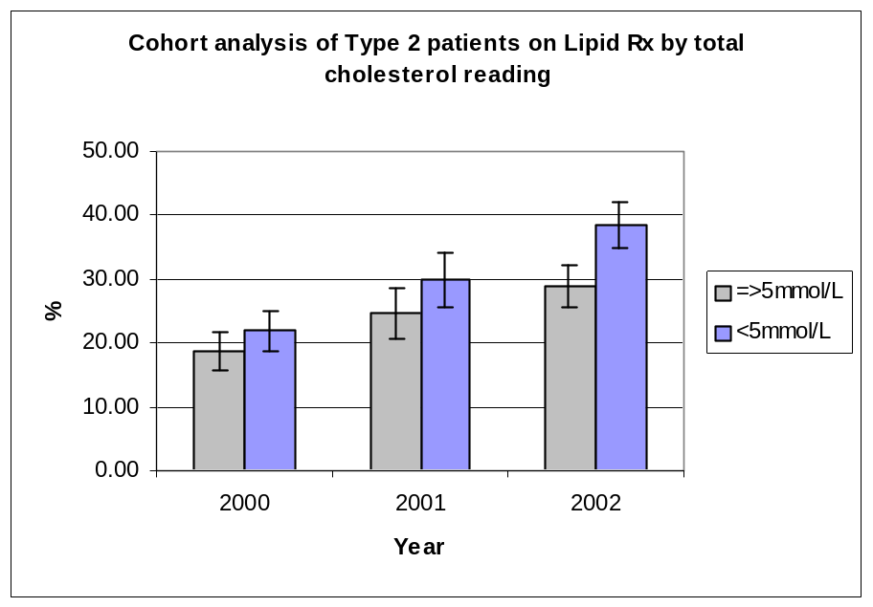 | 7. Cohort analysis of Type 2 patients) on Lipid treatment.  The McNemar test for related samples for dichotomous variables was used to test the difference between Type 2 cohort patients on lipid therapy in the period 2000 to 2002. Comparisons between 2000 & 2002 and 2001 & 2002 were significant.  McNemar test:  2000 Lipid Rx – 2002 Lipid Rx (n=341; Chi sq = 6.113; p<0.05)  2001 Lipid Rx – 2002 Lipid Rx (n=327; Chi sq =6.7805; p<0.05)
  Type 2 cohort with => 5mmol/L on lipid rx |  | 2000 | 2001 | 2002
  Lipid rx | n | 64 | 47 | 78
   | % | 18.70 | 24.70 | 28.90
   | CI | 3.06 | 4.06 | 3.37
   | lower | 15.64 | 20.64 | 25.53
   | upper | 21.76 | 28.76 | 32.27
  Type 2 cohort with < 5mmol/L on lipid rx
  Lipid rx | n | 62 | 73 | 163
   | % | 21.90 | 30.00 | 38.40
   | CI | 3.24 | 4.32 | 3.62
   | lower | 18.66 | 25.68 | 34.78
   | upper | 25.14 | 34.32 | 42.02
  Total |  | 625 | 433 | 695
8. Cohort analysis of Type 2 patients with >130/85 mm/Hg on ACEi  The results of the cohort analysis of Type 2 patients (>130/85 mm/Hg) show that there were significant differences between the % in 2000 to 2002 and between 2001 to 2002. These results were tested with the McNemar test for related samples for dichotomous variables for Type 2 cohort patients on ACEi..  McNemar test:  2000 ACEi – 2002 ACEi (n=327; Chi sq = 27.191; p<0.0005)  2001 ACEi – 2002 ACEi (n=341; Chi sq =3.521; p=0.061) | 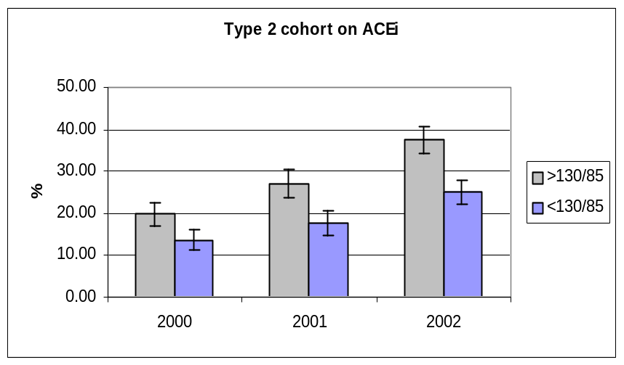
  Type 2 cohort with > 130/85 mm/Hg on ACEi |  | 2000 | 2001 | 2002
  ACEi | n | 117 | 125 | 256
   | % | 19.90 | 27.10 | 37.50
   | CI | 2.81 | 3.53 | 3.10
   | lower | 17.09 | 23.57 | 34.40
   | upper | 22.71 | 30.63 | 40.60
  Type 2 cohort with < 130/85 mm/Hg on ACEi |  | 2000 | 2001 | 2002
  ACEi | n | 26 | 26 | 63
   | % | 13.70 | 17.70 | 25.10
   | CI | 2.42 | 3.03 | 2.78
   | lower | 11.28 | 14.67 | 22.32
   | upper | 16.12 | 20.73 | 27.88
  Total |  | 777 | 608 | 934
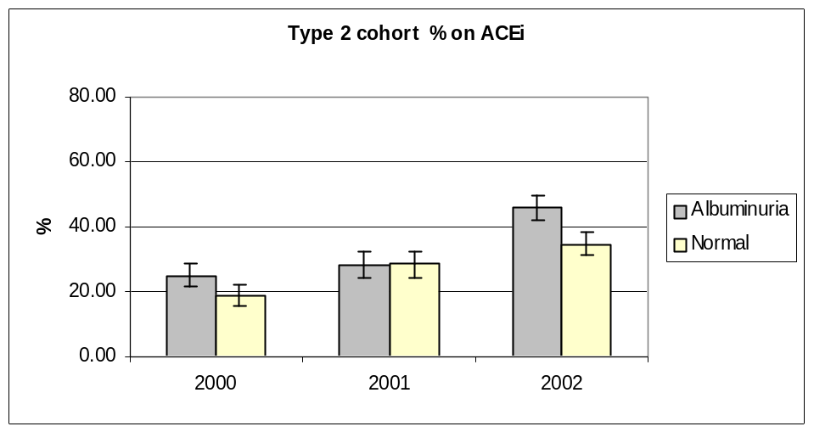 | 9. Cohort analysis of Type 2 patients with albuminuria on ACEi
  Type 2 cohort with albuminuria on ACEi |  | 2000 | 2001 | 2002
  ACEi | n | 21 | 17 | 54
   | % | 25.00 | 28.33 | 46.15
   | CI | 3.50 | 4.12 | 3.74
   | lower | 21.50 | 24.21 | 42.41
   | upper | 28.50 | 32.45 | 49.89
  Type 2 cohort without albuminuria on ACEi |  | 2000 | 2001 | 2002
  ACEi | n | 55 | 73 | 146
   | % | 18.80 | 28.40 | 34.80
   | CI | 3.16 | 4.12 | 3.57
   | lower | 15.64 | 24.28 | 31.23
   | upper | 21.96 | 32.52 | 38.37
   | Total n | 587 | 460 | 683
10. Cohort analysis of Type 2 HbA1c groupings and medication (2000-2002) | 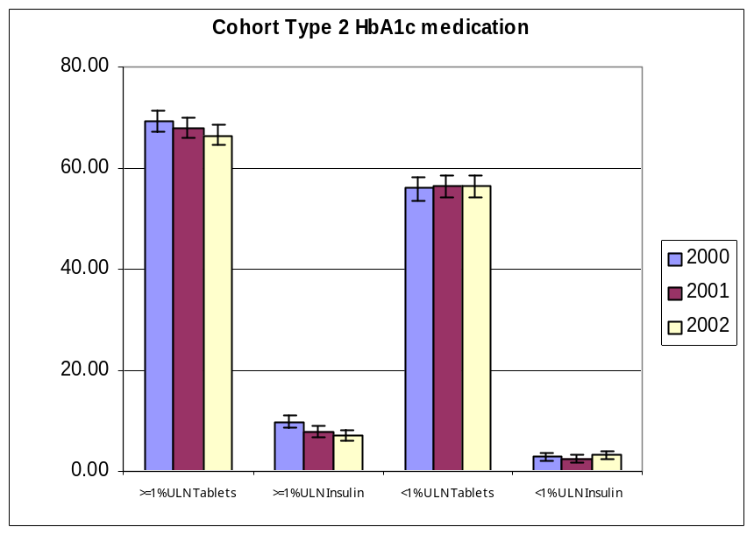
  All Cohort Type 2 HbA1c >1%ULN |  | 2000 | 2001 | 2002
   | Total n | 1976 | 2075 | 1962
  >=1%ULN Tablets | n | 591 | 555 | 518
   | % | 69.28 | 67.93 | 66.58
   | CI | 2.03 | 2.01 | 2.09
  >=1%ULN Insulin | n | 83 | 88 | 71
   | % | 9.73 | 7.8 | 7.1
   | CI | 1.31 | 1.15 | 1.14
  All Cohort Type 2 HbA1c <1%ULN |  | 2000 | 2001 | 2002
  <1% ULN Tablets | n | 628 | 710 | 668
   | % | 55.90 | 56.40 | 56.40
   | CI | 2.19 | 2.13 | 2.19
  <1% ULN Insulin | n | 32 | 33 | 37
   | % | 2.8 | 2.6 | 3.1
   | CI | 0.73 | 0.68 | 0.77

